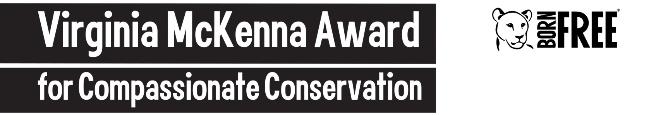

﻿Details

Name of applicant:

Project title:

Country where work is taking place:

Organisation information:

Current job/title:

Name of organisation:

Status (e.g., NGO, charity, non-profit, university):

Date established: Charity number (if available):

Contact details:

Address:

Email:

Phone:

Skype:

Twitter:

Facebook:

Website:

Contact details for two referees:

Name:

Institution:

Email:

Phone:

Name:

Institution:

Email:

Phone:

Personal Statement:

(in 300 words tell us why you would be a worthy recipient of the VMA. Describe your personal outlook and vision for conservation and welfare work)

Applicant Background

(500 words or less)

a) Education summary:
b) Current work:
c) Previous related work and achievements:
d) Previous awards:
e) Key publications:
f) Other interests (including languages):

﻿

The Project

Project title
(max 10 words):

Location:
(brief description of project site/s; include map and size of area)

Executive summary:
(max 300 words - Summarise the issues you are addressing, the urgency and scale of your work, what you hope to achieve, and how the VMA funding will help)

Conservation outlook:
(max 200 words - How does your work contribute to welfare and conservation priorities in your area? What do you hope to achieve over the next few years?

Your work:
(max 500 words)

a) Wildlife species targeted by this project:

b) Threat(s) and issue(s) your project is addressing:

c) Project objectives:
(These should be SMART: Specific, Measurable, Achievable, Realistic and Timely)

d) Key project stakeholders:

e) Methods:
(max 300 words - Describe the methods and actions that your project will undertake under each of your objectives to bring about your project’s long-term goal)

f) Overall project budget:

g) How will the VMA funding will be spent:
(provide some indication of specifics that will be funded by the award)

﻿

