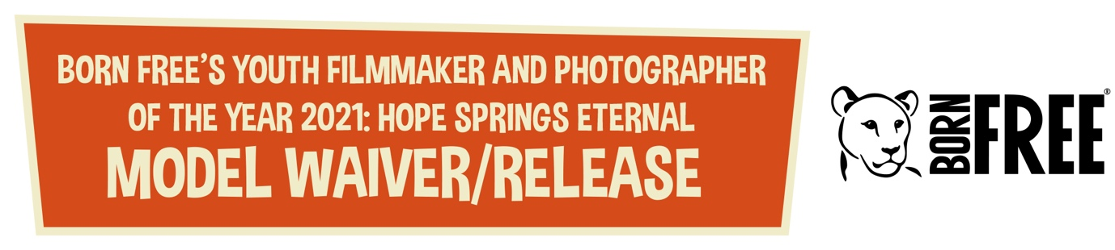

This Agreement is between ............................................... .................. (“Photographer”) and the

following person ................................................................................... (“Model”)

I grant the Photographer the absolute right and permission to copyright and use, re-use, and publish, photographic portraits, pictures or video footage of me or in which I may be included, in whole or in part/voice, without restriction, including but not limited to entering the finished product, or products into Born Free’s Youth Photographer and Filmmaker of the Year Competition.
I waive any right that I may have to inspect or approve the finished product, or products or the copy or printed matter that may be used in connection with it, or the use to which it may be applied.
I understand that the Photographer may transfer permission to use the finished product, or products in any manner or media to a third party (for example, Born Free).
I have read, understood, and agree to the terms of this Agreement. I understand that I am or may be giving up certain legal rights by signing this release.

Model
Date: ...............................................

Printed Name: .........................................................................................................................................

Date of Birth: ...............................................

Signature: .........................................................................................................................................

For Models under the age of 18 years old, a parent or guardian must countersign this agreement.

Parent/Guardian
I acknowledge that I am the parent or guardian of the above named Model and I have the right and ability to consent to the terms herein on their behalf.

Printed Name: .........................................................................................................................................

Signature: .........................................................................................................................................

