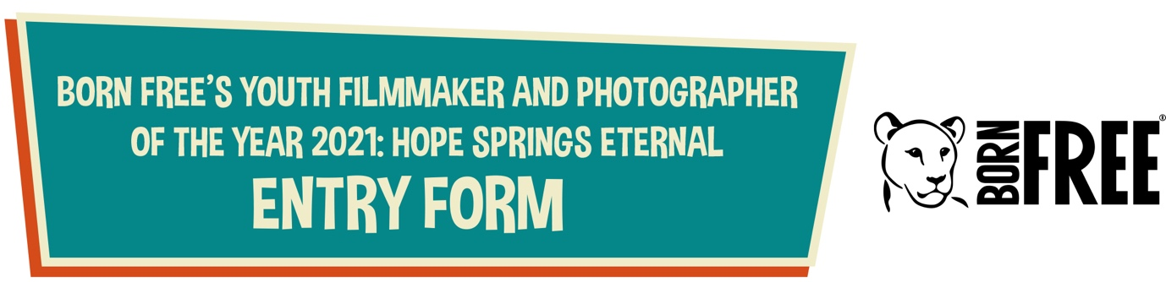

First Name Click or tap here to enter text.
Surname Click or tap here to enter text.
Date of Birth Click or tap here to enter text. (for group entries leave blank)
Which category/sub-category are you submitting your entry for?
Categories
☐ 11 years and under
☐ 16 years and under
Sub-categories:
☐ Photo story
☐ Short film
Have you, or are you planning to submit more than one entry to this competition?
☐ Yes
☐ No
A maximum of two entries (across all categories) can be submitted by one person or group – please complete a new entry form for each entry.
Is this an individual or group entry?
☐ Individual
☐ Group
If you are a group – please list the names of everyone in the group
Click or tap here to enter text.

Are all the members of the group within the relevant age category?
☐ Yes
☐ No
If you are pre-selected, we may ask you to provide dates of birth for each group member.

Do you live in the UK?
☐ Yes
☐ No
Did you use food, water or housing to attract wildlife to your garden?
☐ Yes
☐ No
If yes, please give us a few details: Click or tap here to enter text.
About your entry:
- Was the photo story/film taken in the UK?
☐ Yes
☐ No
- The title of your entry Click or tap here to enter text.
- Did you have any assistance?
☐ Yes
☐ No
If yes, who helped you and what did they do to help?
Click or tap here to enter text.
Don’t forget that if you are pre-selected for the shortlist, you will be asked to provide a waiver signed by any people featured in your photo story/film or their parent/guardian – these can be downloaded from www.bornfree.org.uk/kids-competition
Supporting paragraph
Please include information about:
- How, when and where your photo story/film was taken
- The story that your photo story/film is telling
- If you used food, water or shelter to attract wildlife to an area
- How it was edited (if at all) and the equipment you used.
Click or tap here to enter text.
And finally:
Have you attached your photo story/film files?
☐ Yes
☐ No
Is your parent/guardian aware that you are entering this competition?
☐ Yes
☐ No
☐ N/A for a class entry being submitted by a teacher or teaching assistant
Have you read, and agree to, the competition rules, terms and conditions (available from www.bornfree.org.uk/kids-competition):
☐ Yes
☐ No

PLEASE SUBMIT THIS FORM, ALONG WITH YOUR PHOTO STORY/FILM FILES TO education@bornfree.org.uk
Please include your name in the title of the email and all file attachments
If your photo story/film files are over 15MB, please send them via https://wetransfer.com/
Thank you for your entry.
Winning entries will be announced on 30th June 2021.
Follow the competition on Born Free’s social media, but please ask your parent or teacher to do this for you if you are under 13 years old.

